iion SDK-unity Integration

Step 1: Drag the aar under: /Assets/Plugins/Android/libs

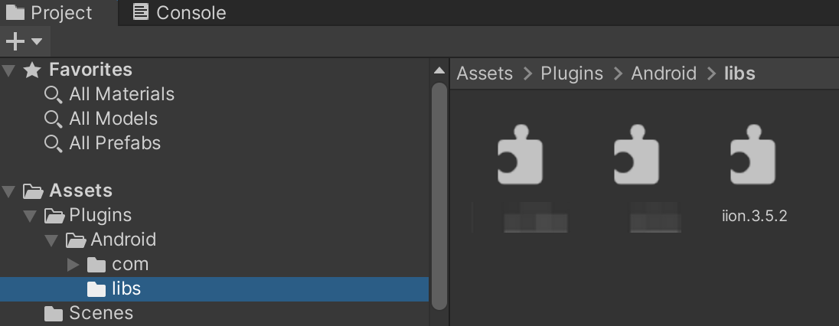

Step 2: Drag the adapter folder and code to the folder /Assets/Plugins/Android/, shown as below:

